**Practical – 2**

**Question – 8**

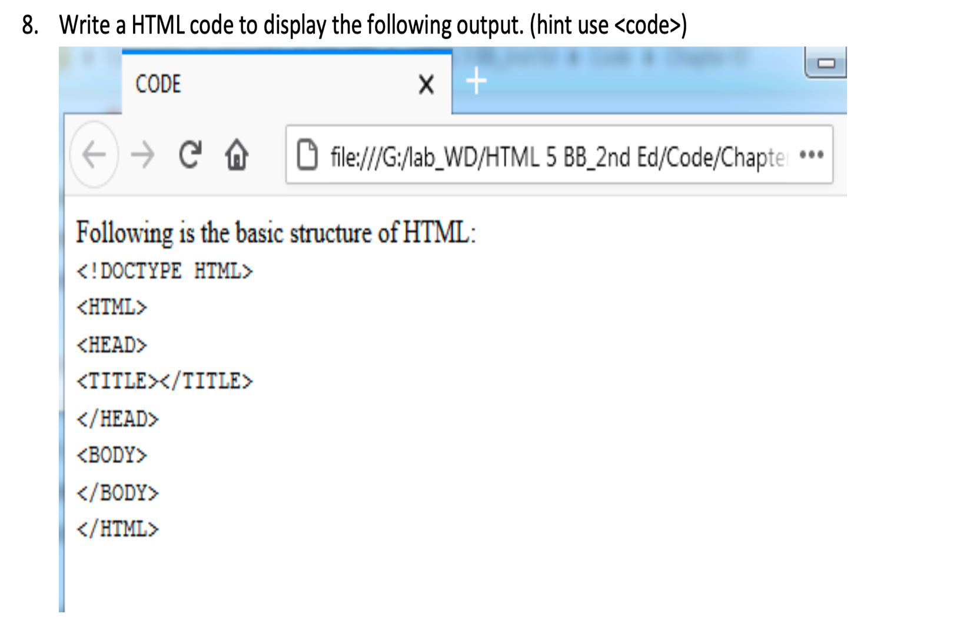

**HTML Code**

<!-- Implementation of code tag -->

<!DOCTYPE html>

<html lang="en">

<head>

<meta charset="UTF-8">

<meta name="viewport" content="width=device-width, initial-scale=1.0">

<title>Code Tag</title>

</head>

<body>

<h4>Following is the basic structure of HTML :</h4>

<code>

&lt;!DOCTYPE HTML&gt;<br>

&lt;HTML&gt;<br>

&lt;HEAD&gt;<br>

&lt;TITLE&gt;&lt;/TITLE&gt;<br>

&lt;/HEAD&gt;

&lt;BODY&gt;<br>

&lt;/BODY&gt;<br>

&lt;/HTML&gt;<br>

</code>

</body>

</html>

**Output**

